Data Mining Project
Sleep Disorder Analysis

Preethi Sri B - 23MIS0470
Yuva Krithikka S - 23MIS0437
Madhumitha B - 23MSO360

Output :
----- Central Tendency Measures -----

Mean values:
Age 0.486883
Gender 0.508000
Sleep_Disorder_Type 2.055000
AHI_Score 0.514212
SaO2_Level 0.500516
Diagnosis_Confirmed 0.884000
Smoking_Habit 0.474000
Alcohol_Consumption 1.012000
Exercise_Frequency 3.438000
Caffeine_Intake 1.010000
Work_Shift 0.971000
dtype: float64

Median values:
Age 0.480519
Gender 1.000000
Sleep_Disorder_Type 3.000000
AHI_Score 0.527817
SaO2_Level 0.505613
Diagnosis_Confirmed 1.000000
Smoking_Habit 0.000000
Alcohol_Consumption 1.000000
Exercise_Frequency 3.000000
Caffeine_Intake 1.000000
Work_Shift 1.000000
dtype: float64

Mode values:
Age 0.792208
Gender 1.000000
Sleep_Disorder_Type 3.000000
AHI_Score 0.129678
SaO2_Level 0.524860
Diagnosis_Confirmed 1.000000
Smoking_Habit 0.000000
Alcohol_Consumption 2.000000
Exercise_Frequency 4.000000
Caffeine_Intake 2.000000
Work_Shift 1.000000
Name: 0, dtype: float64

----- Range, Quartiles & IQR -----
Range (Max - Min):
Age 1.0
Gender 1.0
Sleep_Disorder_Type 4.0
AHI_Score 1.0
SaO2_Level 1.0
Diagnosis_Confirmed 1.0
Smoking_Habit 1.0
Alcohol_Consumption 2.0
Exercise_Frequency 7.0
Caffeine_Intake 2.0
Work_Shift 2.0
dtype: float64

Quartiles (Q1, Q2, Q3):
Q1:
Age 0.233766
Gender 0.000000
Sleep_Disorder_Type 0.000000
AHI_Score 0.268761
SaO2_Level 0.254010
Diagnosis_Confirmed 1.000000
Smoking_Habit 0.000000
Alcohol_Consumption 0.000000
Exercise_Frequency 1.000000
Caffeine_Intake 0.000000
Work_Shift 0.000000
Name: 0.25, dtype: float64
Q2 (Median):
Age 0.480519
Gender 1.000000
Sleep_Disorder_Type 3.000000
AHI_Score 0.527817
SaO2_Level 0.505613
Diagnosis_Confirmed 1.000000
Smoking_Habit 0.000000
Alcohol_Consumption 1.000000
Exercise_Frequency 3.000000
Caffeine_Intake 1.000000
Work_Shift 1.000000
Name: 0.5, dtype: float64
Q3:
Age 0.740260
Gender 1.000000
Sleep_Disorder_Type 3.000000
AHI_Score 0.762157
SaO2_Level 0.753408
Diagnosis_Confirmed 1.000000
Smoking_Habit 1.000000
Alcohol_Consumption 2.000000
Exercise_Frequency 5.000000
Caffeine_Intake 2.000000
Work_Shift 2.000000
Name: 0.75, dtype: float64

Interquartile Range (IQR):
Age 0.506494
Gender 1.000000
Sleep_Disorder_Type 3.000000
AHI_Score 0.493396
SaO2_Level 0.499399
Diagnosis_Confirmed 0.000000
Smoking_Habit 1.000000
Alcohol_Consumption 2.000000
Exercise_Frequency 4.000000
Caffeine_Intake 2.000000
Work_Shift 2.000000
dtype: float64
----- Five Number Summary -----
Minimum Q1 (25%) Median (Q2) Q3 (75%) Maximum
Age 0.0 0.233766 0.480519 0.740260 1.0
Gender 0.0 0.000000 1.000000 1.000000 1.0
Sleep_Disorder_Type 0.0 0.000000 3.000000 3.000000 4.0
AHI_Score 0.0 0.268761 0.527817 0.762157 1.0
SaO2_Level 0.0 0.254010 0.505613 0.753408 1.0
Diagnosis_Confirmed 0.0 1.000000 1.000000 1.000000 1.0
Smoking_Habit 0.0 0.000000 0.000000 1.000000 1.0
Alcohol_Consumption 0.0 0.000000 1.000000 2.000000 2.0
Exercise_Frequency 0.0 1.000000 3.000000 5.000000 7.0
Caffeine_Intake 0.0 0.000000 1.000000 2.000000 2.0
Work_Shift 0.0 0.000000 1.000000 2.000000 2.0
----- Outlier Detection using IQR -----

Age:
Lower Bound = -0.525974025974026, Upper Bound = 1.5
Outliers: None

Gender:
Lower Bound = -1.5, Upper Bound = 2.5
Outliers: None

Sleep_Disorder_Type:
Lower Bound = -4.5, Upper Bound = 7.5
Outliers: None

AHI_Score:
Lower Bound = -0.4713327996798081, Upper Bound = 1.5022513508104867
Outliers: None

SaO2_Level:
Lower Bound = -0.4950882117080991, Upper Bound = 1.5025060144346436
Outliers: None

Diagnosis_Confirmed:
Lower Bound = 1.0, Upper Bound = 1.0
Outliers: [0 0 0 0 0 0 0 0 0 0 0 0 0 0 0 0 0 0 0 0 0 0 0 0 0 0 0 0 0 0 0 0 0 0 0 0 0
0 0 0 0 0 0 0 0 0 0 0 0 0 0 0 0 0 0 0 0 0 0 0 0 0 0 0 0 0 0 0 0 0 0 0 0 0
0 0 0 0 0 0 0 0 0 0 0 0 0 0 0 0 0 0 0 0 0 0 0 0 0 0 0 0 0 0 0 0 0 0 0 0 0
0 0 0 0 0]

Smoking_Habit:
Lower Bound = -1.5, Upper Bound = 2.5
Outliers: None

Alcohol_Consumption:
Lower Bound = -3.0, Upper Bound = 5.0
Outliers: None

Exercise_Frequency:
Lower Bound = -5.0, Upper Bound = 11.0
Outliers: None

Caffeine_Intake:
Lower Bound = -3.0, Upper Bound = 5.0
Outliers: None

Work_Shift:
Lower Bound = -3.0, Upper Bound = 5.0
Outliers: None
----BoxPlot----
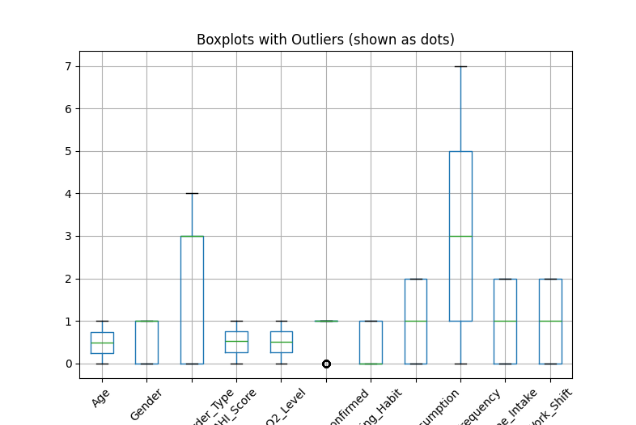
----- Variance -----
Age 0.086601
Gender 0.250186
Sleep_Disorder_Type 2.290265
AHI_Score 0.082180
SaO2_Level 0.082866
Diagnosis_Confirmed 0.102647
dtype: float64

----- Standard Deviation -----
Age 0.294281
Gender 0.500186
Sleep_Disorder_Type 1.513362
AHI_Score 0.286670
SaO2_Level 0.287865
Diagnosis_Confirmed 0.320385
dtype: float64
----- Covariance Matrix -----
Age Gender ... SaO2_Level Diagnosis_Confirmed
Age 0.086601 0.002094 ... 0.001456 -0.000574
Gender 0.002094 0.250186 ... 0.005833 -0.011083
Sleep_Disorder_Type -0.006343 -0.007948 ... -0.029732 0.008388
AHI_Score 0.000773 -0.000813 ... -0.002168 0.043055
SaO2_Level 0.001456 0.005833 ... 0.082866 -0.032164
Diagnosis_Confirmed -0.000574 -0.011083 ... -0.032164 0.102647

[6 rows x 6 columns]

----- Correlation Matrix -----
Age Gender ... SaO2_Level Diagnosis_Confirmed
Age 1.000000 0.014226 ... 0.017190 -0.006089
Gender 0.014226 1.000000 ... 0.040510 -0.069160
Sleep_Disorder_Type -0.014243 -0.010500 ... -0.068248 0.017301
AHI_Score 0.009158 -0.005671 ... -0.026270 0.468780
SaO2_Level 0.017190 0.040510 ... 1.000000 -0.348742
Diagnosis_Confirmed -0.006089 -0.069160 ... -0.348742 1.000000

[6 rows x 6 columns]
Chi-Square Test Results:
Chi2 Value: 73.7894421072609
p-value: 0.5825637929794798
Degrees of Freedom: 77

---Quantile Plot---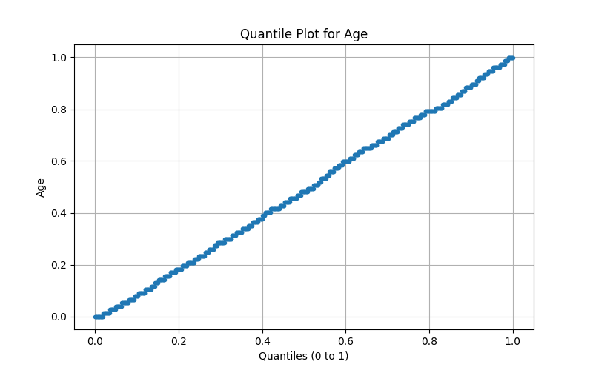
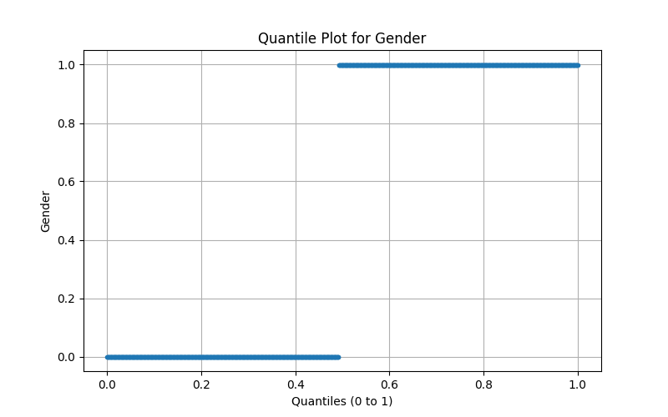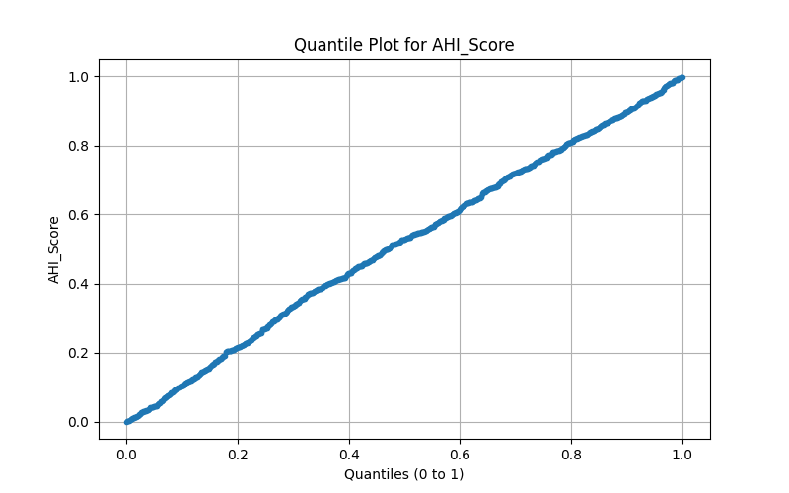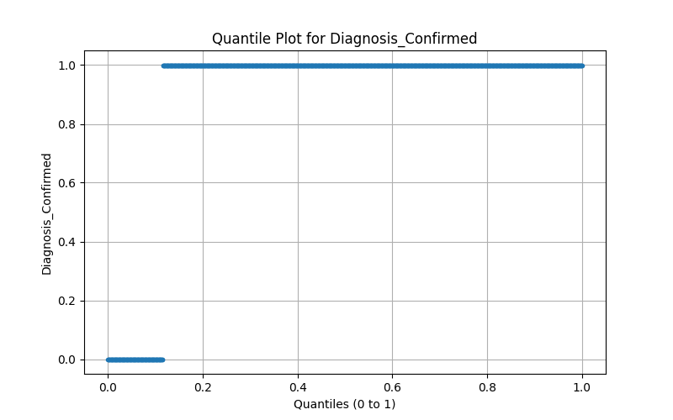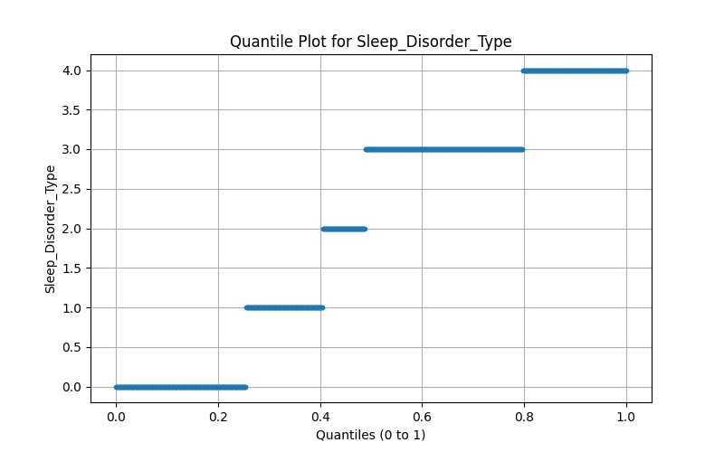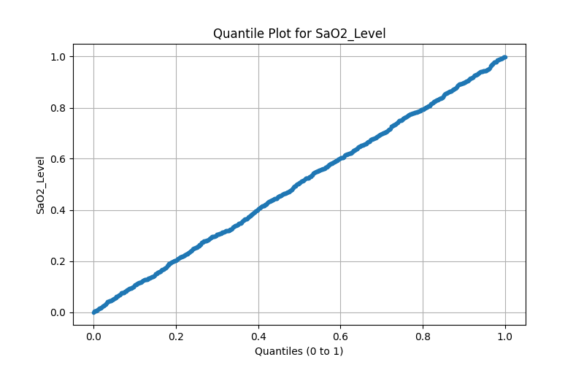

---Q-Q Plot---
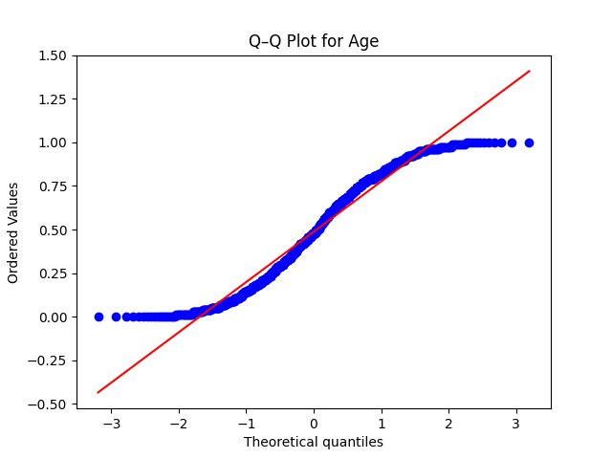
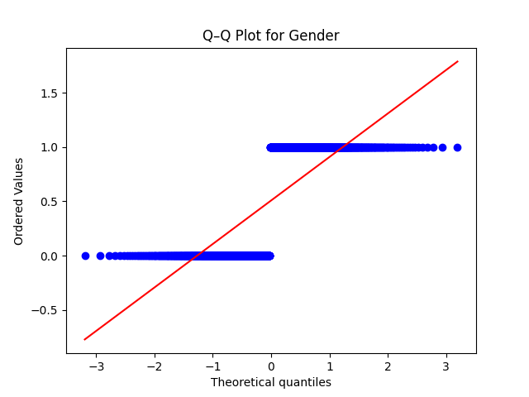
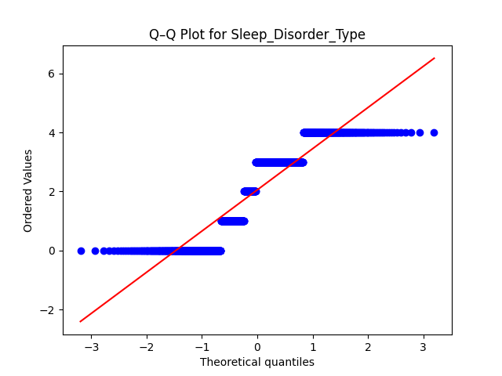
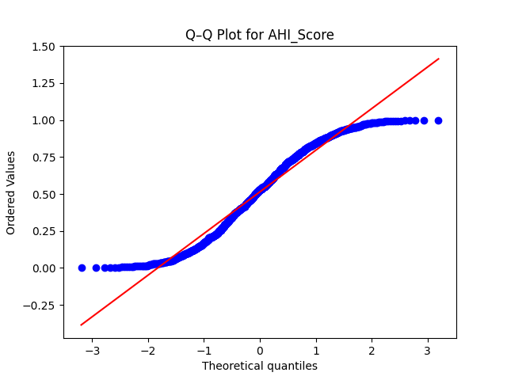
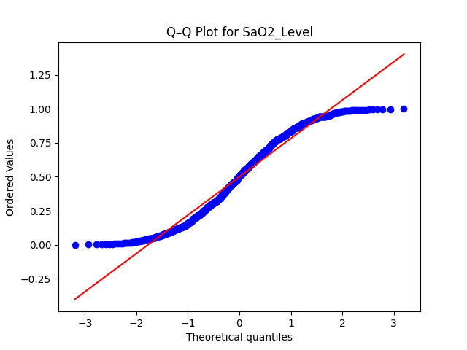
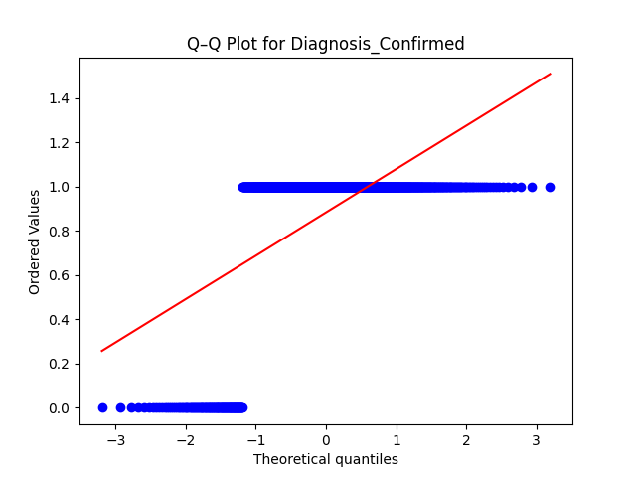

---Histogram---
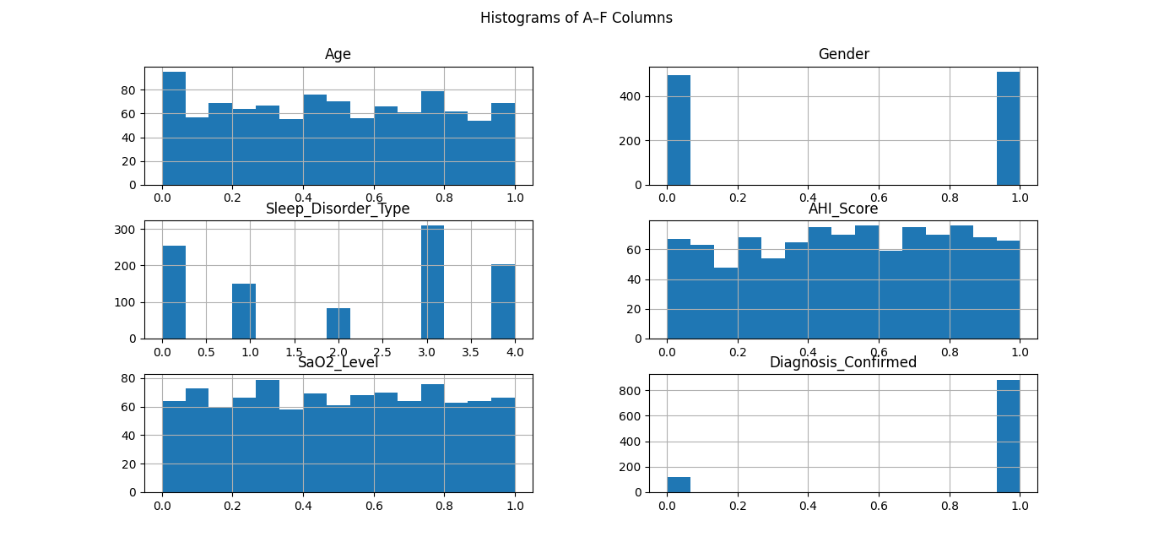
---Scatter Plot---
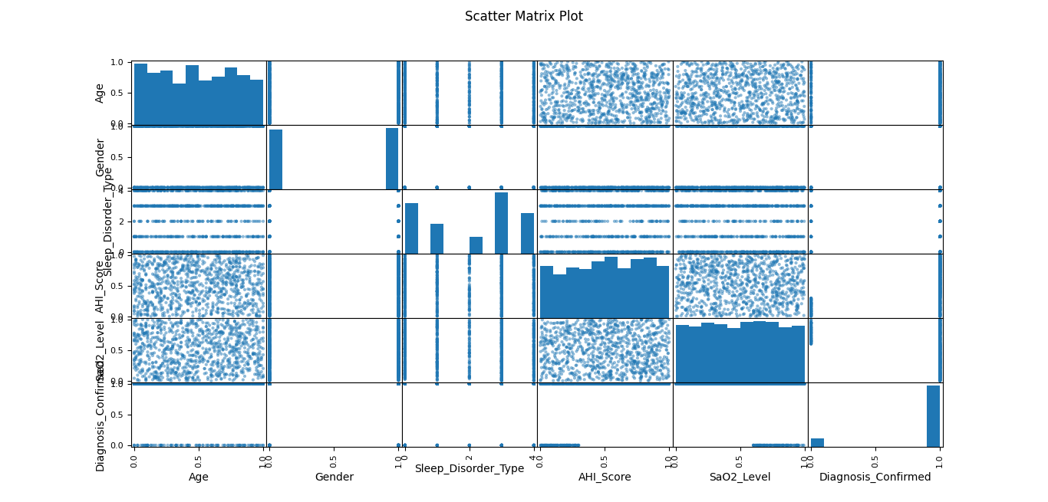
----- Pearson Correlation -----
Age Gender ... SaO2_Level Diagnosis_Confirmed
Age 1.000000 0.014226 ... 0.017190 -0.006089
Gender 0.014226 1.000000 ... 0.040510 -0.069160
Sleep_Disorder_Type -0.014243 -0.010500 ... -0.068248 0.017301
AHI_Score 0.009158 -0.005671 ... -0.026270 0.468780
SaO2_Level 0.017190 0.040510 ... 1.000000 -0.348742
Diagnosis_Confirmed -0.006089 -0.069160 ... -0.348742 1.000000

[6 rows x 6 columns]

----- Cosine Similarity -----
Age Gender ... SaO2_Level Diagnosis_Confirmed
Age 1.000000 0.615220 ... 0.746494 0.803688
Gender 0.615220 1.000000 ... 0.632081 0.653606
Sleep_Disorder_Type 0.684966 0.569645 ... 0.678051 0.760699
AHI_Score 0.749999 0.620672 ... 0.750955 0.899029
SaO2_Level 0.746494 0.632081 ... 1.000000 0.755934
Diagnosis_Confirmed 0.803688 0.653606 ... 0.755934 1.000000

[6 rows x 6 columns]
---Minkowshki Distance---
Minkowski Distance (p=3) between Row1 & Row2: 0.4940014661133043

---Disimilarity Measures---
Euclidean Distance: 0.5278025128305488
Manhattan Distance: 0.746778113004505
Supremum (Chebyshev) Distance: 0.48051948051948057

---Dissimilarity Matrix---
Euclidean Dissimilarity Matrix:
[[0. 0.52780251 4.20553317 ... 1.60766132 4.06846346 1.03259676]
[0.52780251 0. 4.24304233 ... 1.72192103 4.10054988 0.71813008]
[4.20553317 4.24304233 0. ... 3.00231509 1.11785133 4.2081435 ]
...
[1.60766132 1.72192103 3.00231509 ... 0. 3.1896826 1.66914412]
[4.06846346 4.10054988 1.11785133 ... 3.1896826 0. 4.08969082]
[1.03259676 0.71813008 4.2081435 ... 1.66914412 4.08969082 0. ]]

Manhattan Dissimilarity Matrix:
[[0. 0.74677811 6.36286388 ... 3.28283478 4.96301645 1.71259444]
[0.74677811 0. 6.6869884 ... 3.6069593 5.28714097 1.07567999]
[6.36286388 6.6869884 0. ... 3.15010898 1.84170789 6.09294804]
...
[3.28283478 3.6069593 3.15010898 ... 0. 4.71757294 3.24305702]
[4.96301645 5.28714097 1.84170789 ... 4.71757294 0. 5.44114944]
[1.71259444 1.07567999 6.09294804 ... 3.24305702 5.44114944 0. ]]

Supremum (Chebyshev) Dissimilarity Matrix:
[[0. 0.48051948 4. ... 1. 4. 0.78727236]
[0.48051948 0. 4. ... 1. 4. 0.57594557]
[4. 4. 0. ... 3. 1. 4. ]
...
[1. 1. 3. ... 0. 3. 1. ]
[4. 4. 1. ... 3. 0. 4. ]
[0.78727236 0.57594557 4. ... 1. 4. 0. ]]

---SIMMILARITY AND DISSIMILARITY FOR(ORDINAL,NOMINAL,BINARY)---
Nominal/Categorical (Simple Matching):
0 1 2 3 4 5 6 ... 993 994 995 996 997 998 999
0 0.00 0.50 0.83 0.67 0.67 0.83 0.67 ... 0.67 0.67 0.67 0.67 0.83 0.67 0.50
1 0.50 0.00 0.83 0.67 0.67 0.83 0.67 ... 0.67 0.50 0.67 0.67 0.83 0.67 0.50
2 0.83 0.83 0.00 0.67 0.67 0.50 0.67 ... 0.67 0.83 0.67 0.83 0.67 0.67 0.83
3 0.67 0.67 0.67 0.00 0.83 0.67 0.50 ... 0.50 0.83 0.83 0.83 0.67 0.83 0.67
4 0.67 0.67 0.67 0.83 0.00 0.67 0.83 ... 0.83 0.67 0.33 0.67 0.83 0.50 0.67
.. ... ... ... ... ... ... ... ... ... ... ... ... ... ... ...
995 0.67 0.67 0.67 0.83 0.33 0.67 0.83 ... 0.83 0.67 0.00 0.67 0.83 0.50 0.67
996 0.67 0.67 0.83 0.83 0.67 0.83 0.83 ... 0.83 0.67 0.67 0.00 0.83 0.67 0.67
997 0.83 0.83 0.67 0.67 0.83 0.67 0.67 ... 0.67 0.67 0.83 0.83 0.00 0.83 0.83
998 0.67 0.67 0.67 0.83 0.50 0.67 0.83 ... 0.83 0.67 0.50 0.67 0.83 0.00 0.67
999 0.50 0.50 0.83 0.67 0.67 0.83 0.67 ... 0.67 0.67 0.67 0.67 0.83 0.67 0.00

[1000 rows x 1000 columns]
c:\Users\User\OneDrive\Documents\DataMining Proj\Statistical_Measure.py:190: FutureWarning: DataFrame.applymap has been deprecated. Use DataFrame.map instead.
df_binary = df_selected.applymap(lambda v: 1 if v > df_selected.median().median() else 0)

Binary (Jaccard Distance):
0 1 2 3 4 5 6 ... 993 994 995 996 997 998 999
0 0.00 0.33 0.80 0.60 0.67 0.80 0.40 ... 0.25 0.50 0.33 0.00 0.60 0.75 0.33
1 0.33 0.00 0.75 0.50 0.50 0.75 0.60 ... 0.50 0.33 0.67 0.33 0.50 0.67 0.00
2 0.80 0.75 0.00 0.25 0.67 0.00 0.40 ... 0.60 0.80 0.75 0.80 0.25 0.75 0.75
3 0.60 0.50 0.25 0.00 0.75 0.25 0.20 ... 0.40 0.60 0.80 0.60 0.00 0.80 0.50
4 0.67 0.50 0.67 0.75 0.00 0.67 0.80 ... 0.75 0.67 0.50 0.67 0.75 0.50 0.50
.. ... ... ... ... ... ... ... ... ... ... ... ... ... ... ...
995 0.33 0.67 0.75 0.80 0.50 0.75 0.60 ... 0.50 0.75 0.00 0.33 0.80 0.67 0.67
996 0.00 0.33 0.80 0.60 0.67 0.80 0.40 ... 0.25 0.50 0.33 0.00 0.60 0.75 0.33
997 0.60 0.50 0.25 0.00 0.75 0.25 0.20 ... 0.40 0.60 0.80 0.60 0.00 0.80 0.50
998 0.75 0.67 0.75 0.80 0.50 0.75 0.83 ... 0.80 0.33 0.67 0.75 0.80 0.00 0.67
999 0.33 0.00 0.75 0.50 0.50 0.75 0.60 ... 0.50 0.33 0.67 0.33 0.50 0.67 0.00

[1000 rows x 1000 columns]

Ordinal (Euclidean on Ranks):
0 1 2 3 4 5 6 ... 993 994 995 996 997 998 999
0 0.00 0.53 1.38 0.79 1.21 1.22 0.78 ... 0.72 1.18 0.97 0.59 1.08 1.15 1.03
1 0.53 0.00 1.47 0.97 1.06 1.41 1.11 ... 0.85 1.03 0.93 0.76 1.22 1.25 0.71
2 1.38 1.47 0.00 0.97 0.93 0.46 1.14 ... 1.19 1.22 1.13 1.04 0.58 0.83 1.36
3 0.79 0.97 0.97 0.00 1.27 0.88 0.36 ... 0.39 1.14 1.22 0.88 0.49 1.16 1.10
4 1.21 1.06 0.93 1.27 0.00 1.05 1.47 ... 1.31 0.73 0.60 0.76 1.10 0.59 0.89
.. ... ... ... ... ... ... ... ... ... ... ... ... ... ... ...
995 0.97 0.93 1.13 1.22 0.60 0.98 1.29 ... 1.12 1.00 0.00 0.48 1.24 0.66 1.15
996 0.59 0.76 1.04 0.88 0.76 0.86 0.92 ... 0.85 0.90 0.48 0.00 0.96 0.60 1.02
997 1.08 1.22 0.58 0.49 1.10 0.68 0.73 ... 0.82 1.07 1.24 0.96 0.00 0.98 1.12
998 1.15 1.25 0.83 1.16 0.59 0.79 1.26 ... 1.24 0.82 0.66 0.60 0.98 0.00 1.20
999 1.03 0.71 1.36 1.10 0.89 1.50 1.39 ... 1.15 0.64 1.15 1.02 1.12 1.20 0.00

[1000 rows x 1000 columns]

---Mixed Attributes---
0 1 2 3 4 5 6 ... 993 994 995 996 997 998 999
0 0.00 0.12 0.56 0.27 0.41 0.48 0.27 ... 0.24 0.35 0.28 0.15 0.42 0.33 0.29
1 0.12 0.00 0.61 0.33 0.33 0.55 0.39 ... 0.31 0.25 0.25 0.24 0.48 0.38 0.18
2 0.56 0.61 0.00 0.29 0.29 0.09 0.33 ... 0.39 0.50 0.42 0.43 0.15 0.31 0.52
3 0.27 0.33 0.29 0.00 0.50 0.22 0.09 ... 0.11 0.45 0.46 0.31 0.15 0.42 0.38
4 0.41 0.33 0.29 0.50 0.00 0.36 0.59 ... 0.52 0.23 0.13 0.26 0.43 0.17 0.24
.. ... ... ... ... ... ... ... ... ... ... ... ... ... ... ...
995 0.28 0.25 0.42 0.46 0.13 0.34 0.47 ... 0.39 0.32 0.00 0.15 0.53 0.18 0.34
996 0.15 0.24 0.43 0.31 0.26 0.35 0.34 ... 0.29 0.29 0.15 0.00 0.38 0.20 0.30
997 0.42 0.48 0.15 0.15 0.43 0.20 0.19 ... 0.25 0.36 0.53 0.38 0.00 0.41 0.42
998 0.33 0.38 0.31 0.42 0.17 0.28 0.51 ... 0.49 0.28 0.18 0.20 0.41 0.00 0.41
999 0.29 0.18 0.52 0.38 0.24 0.59 0.47 ... 0.40 0.19 0.34 0.30 0.42 0.41 0.00

[1000 rows x 1000 columns]

